Ipswich Little Theatre Society Inc.
Festival 2018 ENTRY FORM
10, 11 & 12 August – Celebrating 64 years of Drama Festivals 1955 – 2018
Festival Venue: Incinerator Theatre 15 Burley Griffin Drive (Off Griffiths Road) IPSWICH

GROUP NAME: .………………………………………………………………………………………………………………………………….

TITLE OF PLAY: …………………………………………………………………………………………………………………………………..

PLAYWRIGHT: ……………………………………………………………………………………………………………………………….

DIRECTOR: ……………………………………………………………………………………………………………………………….

GENRE: (Comedy, Drama, Farce, Black Comedy) ………………………………………………………………………………..

EXCERPT OF LONGER PLAY: YES NO AUSTRALIAN PLAYWRIGHT: YES NO

ORIGINAL SCRIPT FOR 2018: YES NO ACTUAL RUNNING TIME: MINUTES

CONTAINS LANGUAGE OR MATERIAL THAT MAY OFFEND: YES NO

ENTRY SECTION: OPEN YOUTH 10 MINUTE PLAY

SPECIAL REQUIREMENTS: YES NO
Other than lighting and sound? If yes, please attach a separate sheet with full details.

CONTACT PERSON: …………………………………………………………………………………………………………………..

POSTAL ADDRESS: …………………………………………………………………………………………………………………..

PHONE NUMBER: …………………………………………………………………..................................................

EMAIL ADDRESS: …………………………………………………………………………………………………………………..
PLEASE INDICATE YOUR PREFERRED CHOICE OF SESSIONS.
10 MINUTE: FRI NIGHT 10 AUG
Please note that the Awards presentation will be held after the final 10 Minute Play.
YOUTH: SAT MORN 11 AUG SAT A/NOON 11 AUG
Please note that the Awards presentation will be held after the final Youth Play.
OPEN: SAT NIGHT 11 AUG SUN MORN 12 AUG SUN A/NOON 12 AUG
Please note that the Awards presentation will be held at the conclusion of the Festival.

PAGE 1 OF 6

Ipswich Little Theatre Society Inc.
Festival 2018 ENTRY FORM
10, 11 & 12 August – Celebrating 64 years of Drama Festivals 1955 – 2018
Festival Venue: Incinerator Theatre 15 Burley Griffin Drive (Off Griffiths Road) IPSWICH
CAST DETAILS (Please print clearly)
GROUP NAME: ……………………………………………………………………………………………………………………………….
TITLE OF PLAY: ……………………………………………………………………………………………………………………………….
Name of Actor | Date of Birth  (if 18 years or under) | Character
 | / /
 | / /
 | / /
 | / /
 | / /
 | / /
 | / /
 | / /
 | / /
 | / /
 | / /
 | / /
 | / /
 | / /
 | / /
 | / /
 | / /
 | / /
Page 2 of 6
Ipswich Little Theatre Society Inc.
Festival 2018 ENTRY FORM
10, 11 & 12 August – Celebrating 64 years of Drama Festivals 1955 – 2018
Festival Venue: Incinerator Theatre 15 Burley Griffin Drive (Off Griffiths Road) IPSWICH
SOUND and LIGHTING
All enquiries about sound and lighting should be directed to:
Phil Holmes on 0428 846 611or at p-holmes@hotmail.com
Please keep lighting and sound as basic as possible. It is advisable for you to supply a lighting and sound operator or at least someone to call lighting and sound cues where necessary. All electrical equipment supplied by you for your play must have current test and tag or they will not be able to be used. Please take note of the attached sheet.
SOUND AVAILABLE
* CD Player * Line in to Mixer * USB Stick
NOTE: iPad, iPod, iPhone supported. USB Sticks may cause delays during your allocated Sound and Lighting check times due to compatibility issues and corrupt files. Where possible, you can forward your audio with your script for pre-loading into our system. It will them be ready for the Festival Performance.
LIGHTING AVAILABLE
- Full White Wash or Full Coloured Wash
- Stage Left Wash
- Centre Stage Wash
- Stage Right Wash
NAME OF GROUP: ………………………………………………………………………………………………………
NAMEOF PLAY: ………………………………………………………………………………………………………
LIGHTING/SOUND PERSON: ………………………………………………………………………………………………………….
PHONE NUMBER: ………………………………………………………………………………………………………….
EMAIL ADDRESS: ………………………………………………………………………………………………………….
SOUND:(e.g. CD, iPod, USB) ………………………………………………………………………………………………………….
LIGHTING REQUIRED:
STAGE LEFT WASH CENTRE STAGE WASH STAGE RIGHT WASH
COLOURED WASH LEFT COLOURED WASH CENTRE COLOURED WASH RIGHT FULL WASH
Page 3 of 6
Ipswich Little Theatre Society Inc.
Festival 2018 ENTRY FORM
10, 11 & 12 August – Celebrating 64 years of Drama Festivals 1955 – 2018
Festival Venue: Incinerator Theatre 15 Burley Griffin Drive (Off Griffiths Road) IPSWICH

Stage Plan– provided for your information (do not add your requirements here)

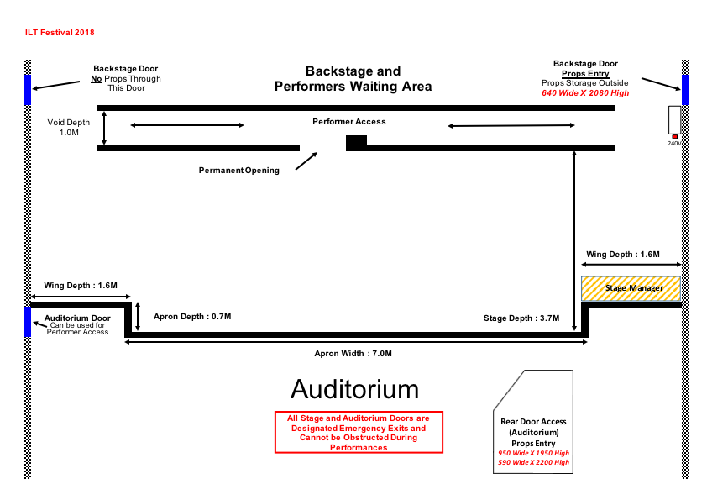

Stage Information:
The Acting Area of the stage is 7 metres wide x 3.7metres deep. Please note that the backstage access door is only 640 wide and 2080 high and will not accommodate large props. Please contact the Festival Director to discuss options to bring large props backstage.

Page 4 of 6
Ipswich Little Theatre Society Inc.
Festival 2018 ENTRY FORM
10, 11 & 12 August – Celebrating 64 years of Drama Festivals 1955 – 2018
Festival Venue: Incinerator Theatre 15 Burley Griffin Drive (Off Griffiths Road) IPSWICH

CONDITIONS OF ENTRY

- The OPEN section is open to actors, directors and crew of all ages. Plays must be at least 20 minutes in length and no longer than 50 minutes and have at least 2 speaking parts.
- The YOUTH section is open only to actors 18 and under at 31 December 2018. The Director and crew of Youth entries may be any age. Plays must be at least 20 minutes in length and no longer than 50 minutes and have at least 2 speaking parts.
- The 10 MINUTE PLAY section is open to actors, directors and crew of all ages with a performance time of no more than 10 minutes with at least 2 speaking parts.
- Youth entries will be scheduled separately on Saturday morning and afternoon and their Awards presentation will be held following the Saturday afternoon session.
- The entry fee is $20 for the 10 Minute Play section, $25 for the Youth section and $30 for the Open section. Fees are not refundable if the group cancels.
- Payment can be made electronically. Details must be obtained from the Festival Director. Cheques and money orders should be made payable to Ipswich Little Theatre Society.
- Three (3) copies of each script MUST be supplied (please mark any alterations). One is for the Adjudicator, one for the Stage Manager and one for the Lighting and Sound Technicians. The sound and lighting copy MUST show cues. Excerpts from full-length plays are permitted as entries.
- Please send the completed entry form, entry fee payment and three (3) copies of the script (as above) to Festival Director, ILT One Act Play Festival, 94 Workshops Street, Brassall, 4305. Your entry pack must be received by Friday 13 July 2018.
It is recommended that you retain these Conditions of Entry for reference.
- The Festival Committee reserves the right to decline any entry. In the event of any dispute or protest, the decision of the Executive Committee of Ipswich Little Theatre Society Inc will be final and binding.
- Awards are decided by the Adjudicator and the decision is final and binding. No correspondence will be entered into.
- Groups entering more than one play are required to nominate the order of priority for inclusion in the festival in the event that more entries are received than can be programmed.
- LATE ENTRIES MIGHT NOT BE ACCEPTED. Contact the Festival Director Craig Taylor before posting late entries at cwkmtaylor@optusnet.com.au or 0422 611 812
- It is the responsibility of each group to obtain permission from the author’s agent to perform their plays and to pay royalties.
- Groups are required to arrive at least ONE HOUR prior to the start of their allotted session and to advise the Stage Manager when they have arrived.
- Should another play be withdrawn from your session, every effort will be made to reschedule plays in that session, which is why you must be there one hour before the start.

Ipswich Little Theatre Society Inc.
Festival 2018 ENTRY FORM
10, 11 & 12 August – Celebrating 64 years of Drama Festivals 1955 – 2018
Festival Venue: Incinerator Theatre 15 Burley Griffin Drive (Off Griffiths Road) IPSWICH

- The Festival Stage Manager and Technical Crew will be in complete charge of the stage and back-stage areas during the festival.
- Each group will be responsible for the arrangement of stage setting for their play. Each group in the Youth and Open sections will be allowed ten (10) minutes to set and five (5) minutes to strike. Each group in the 10 Minute section will be allowed five (5) minutes to set and five (5) minutes to strike.
- Where possible, each group will provide a lighting and sound operator/advisor who will be responsible for the technical direction of the production. At all times, the Ipswich Little Theatre Technician will oversee equipment operation. All script marking and cue sheet entries MUST be able to be read in low lighting e.g. pencil and yellow fluoro highlighter are not able to be read.
- Use of the stage prior to set-up is for sound and lighting checks only and is limited to 10 minutes. No rehearsing is permitted on the festival stage throughout the festival weekend.
- No curtain calls are permitted.
- Each group will be allocated time to view the stage prior to each session, but once a session has begun, there will be no admittance within the stage area until the allotted time.
- Simple furniture or props may be available from ILT but must be requested from the Festival Director by Friday 13 July 2018.
- Where possible cast and crew of each play will be allowed to watch the other plays in the session in which they have performed. However priority is given to paid ticket holders and, as the Incinerator Theatre is a small venue, there may not be seats available for cast and crew. We will provide a CCTV image of the performances in the Courtyard Bar.

Ipswich Little Theatre would like to take this opportunity to thank our generous sponsors who have again whole-heartedly supported our Festival and helped us to continue our 64 year tradition.

Ipswich Little Theatre Society Inc.
Festival 2018 ENTRY FORM
10, 11 & 12 August – Celebrating 64 years of Drama Festivals 1955 – 2018
Festival Venue: Incinerator Theatre 15 Burley Griffin Drive (Off Griffiths Road) IPSWICH

AWARDS FOR 2018

All awards are subject to a minimum number of entries and are awarded at the Adjudicator’s discretion.
10 MINUTE PLAY Section

Best Play - $100
Runner-up - $70
Best Director
Best Actor & Best Actress
Best Supporting Actor & Best Supporting Actress
Best New Australian 10 Minute Script, first performed in 2018 – Ian Pullar Award
Incentive Certificates

YOUTH Section
Best Play - $150
Highly Commended Play - $100
Best Director
Best Youth Actor & Best Youth Actress
Best Supporting Youth Actor & Best Supporting Youth Actress
Best Youth Actor in a Minor Role
Best Youth Actress in a Minor Role
Best New Australian Script, first performed in 2018 – Tony Erhardt Award
Incentive Certificates

OPEN Section

(Cast members 18 years and under in Open Section entries are not eligible for Youth awards).
Best Play Drama - $200
Best Play Comedy - $200
Runner up Drama - $150
Runner up Comedy - $150
Best Director – Patti Jordan Memorial Award
Best Actor in a Dramatic Role
Best Actress in a Dramatic Role
Best Actor in a Comedy Role – Ipswich Little Theatre Life Members’ Award
Best Actress in a Comedy Role - Ipswich Little Theatre Life Members’ Award
Best Supporting Actor
Best Supporting Actress
Best Actor in a Minor Role
Best Actress in a Minor Role
Best New Australian Script, first performed in 2018- Helen Haenke Memorial Prize
Incentive Certificates

